The analysis report

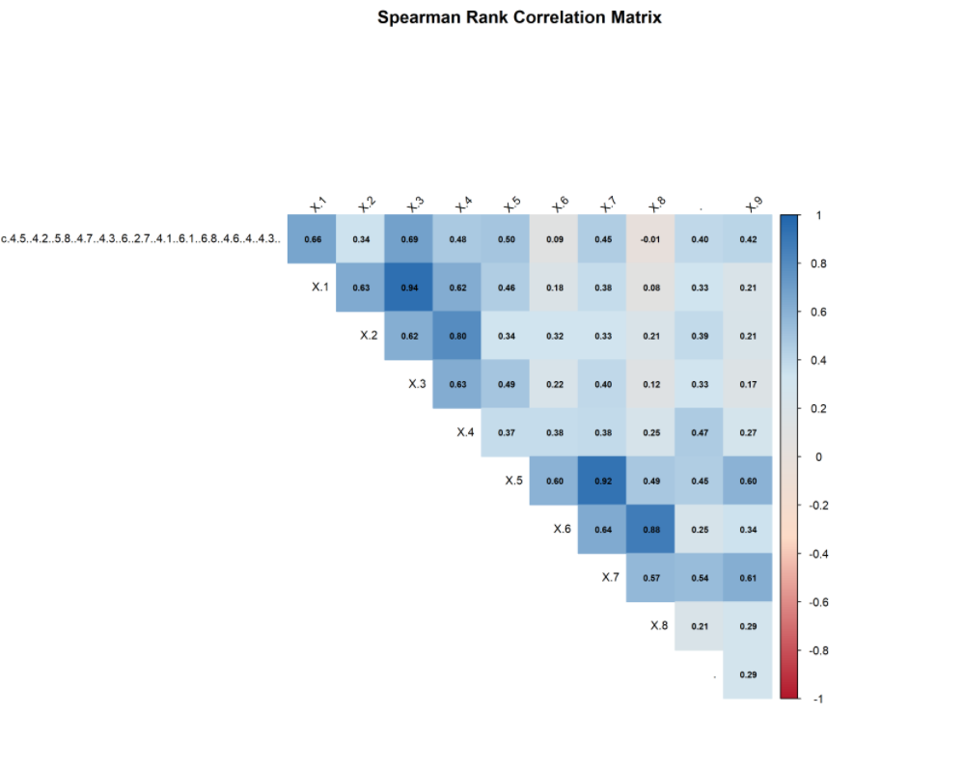
Figure1: Spearson correlation report
The correlation analysis shows both the strength and direction of relationships among the morphometric traits. Positive correlations indicate traits that tend to increase together, whereas negative correlations suggest opposing patterns or trade-offs. The significant correlations support the use of PCA for reducing dimensionality and summarizing the major variation in the data.

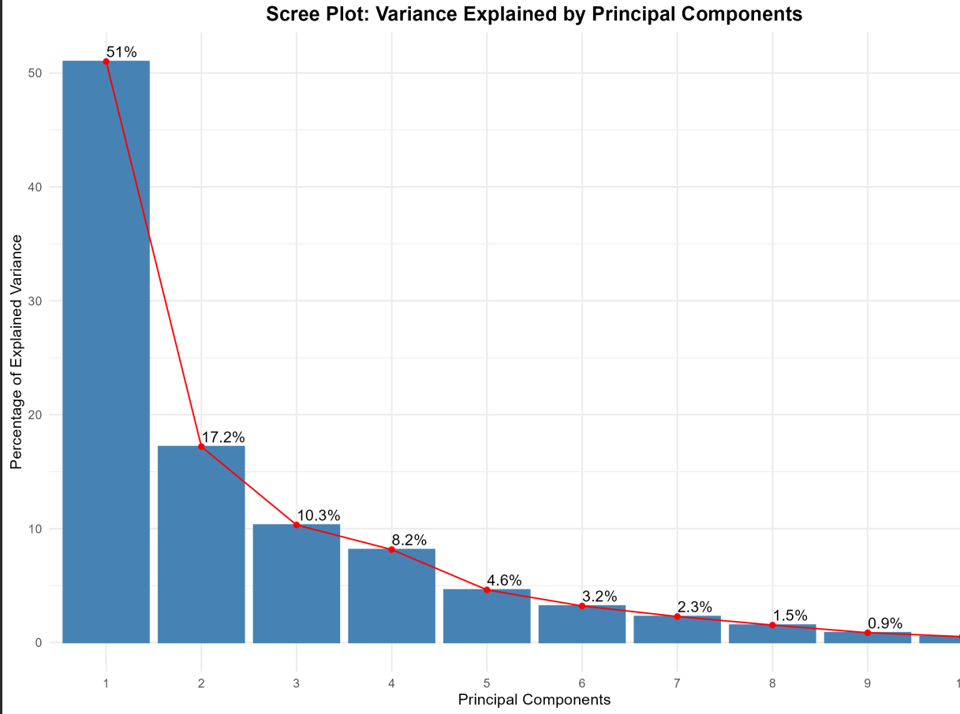
Figure 2: variance explained by each principal component

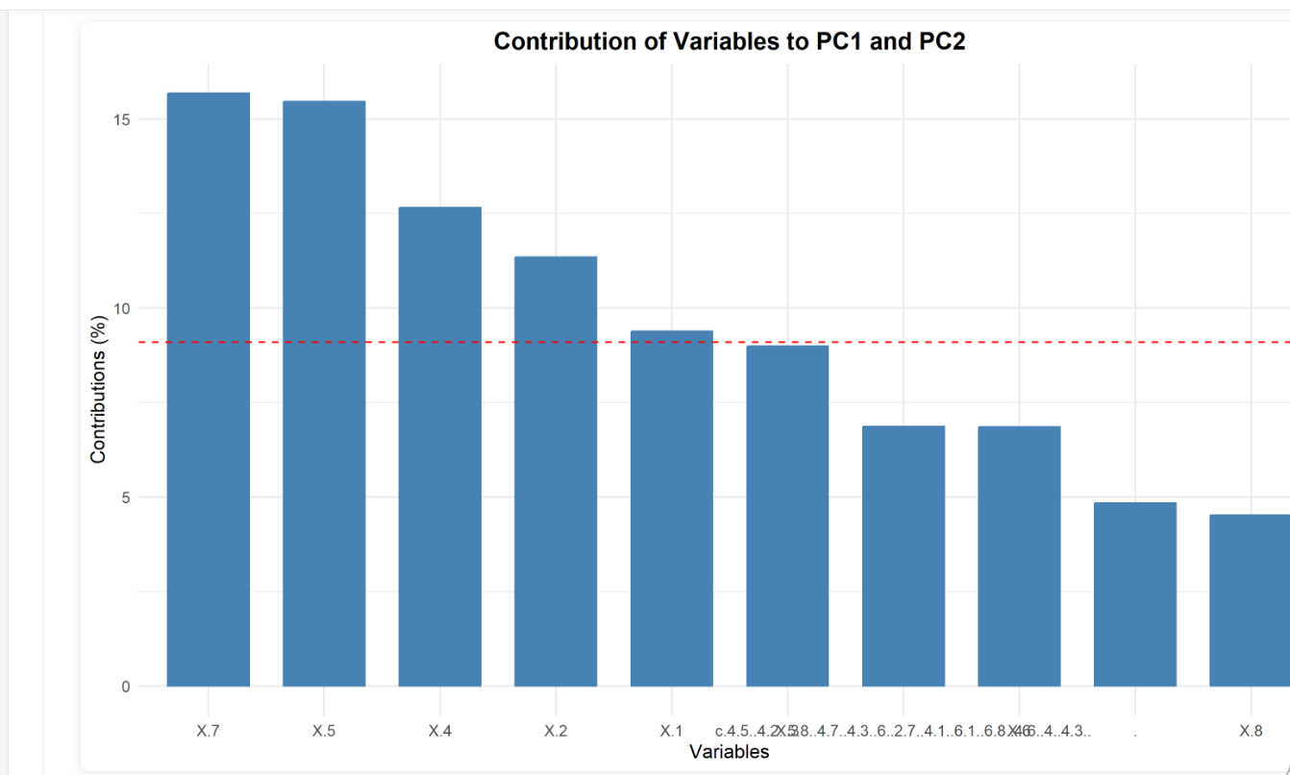
Figure 3: variance showing the principal component
The PCA showed that the first three principal components account for 78.5% of the total variance.
- PC1 explains 51% of variance
- PC2 explains 17.2% of variance
- PC3 explains 10.3% of variance

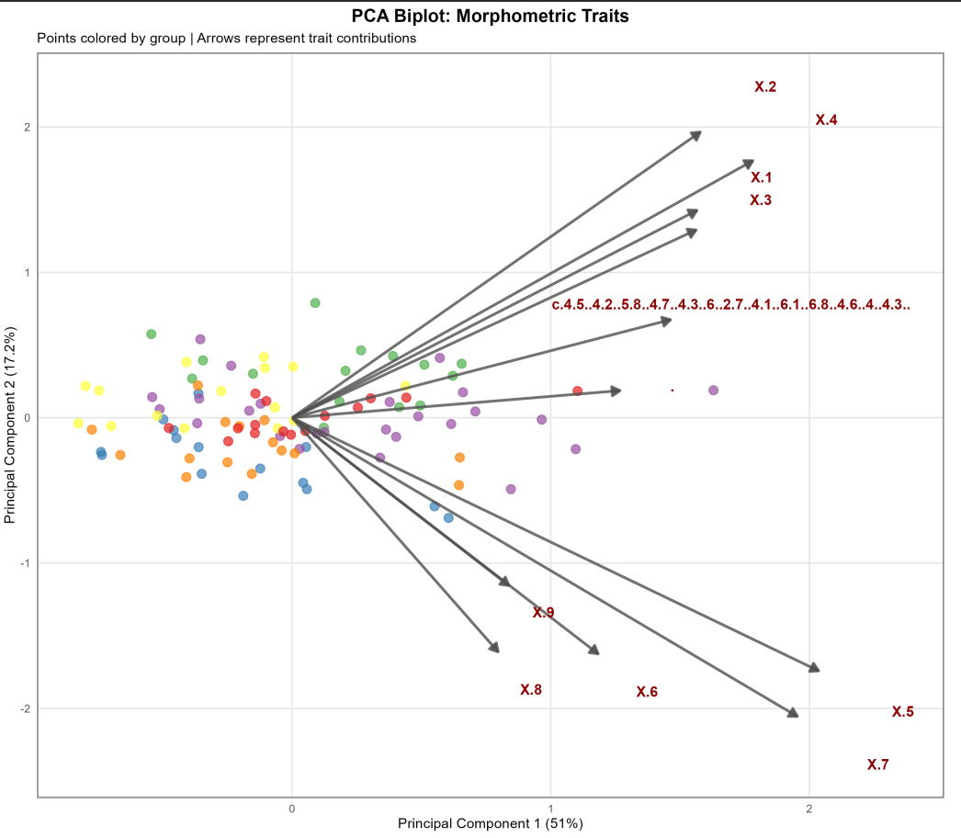
Figure 4: PCA biplot without confidence ellipses
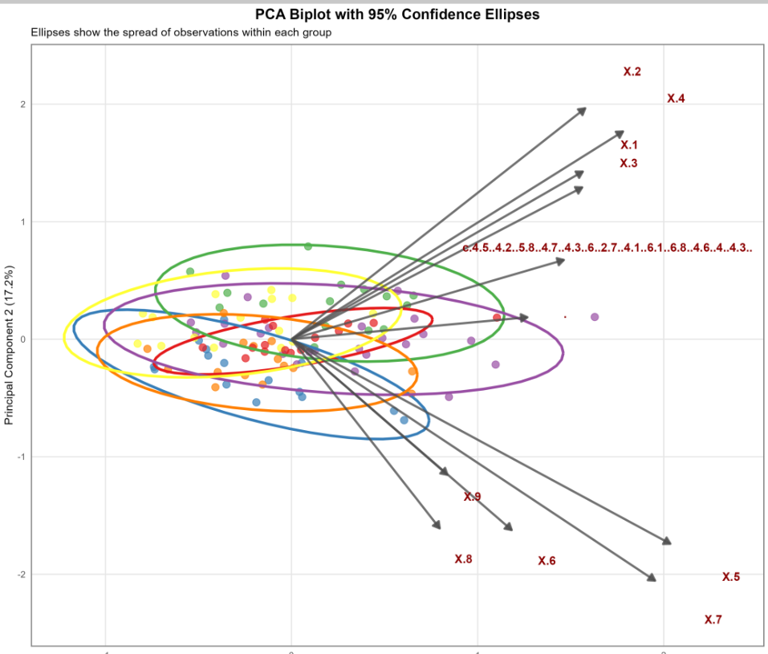
Figure 5: 95% confidence ellipses of the PCA biplot

The PCA biplots with 95% confidence ellipses illustrate how distinctly the groups are separated.
- Á vs Ã: Overlapping (distance = 0.39 units)
- Á vs È: Overlapping (distance = 0.33 units)
- Á vs Ë: Overlapping (distance = 0.21 units)
- Á vs Î: Overlapping (distance = 0.29 units)
- Á vs Õ: Overlapping (distance = 0.38 units)
- Ã vs È: Overlapping (distance = 0.72 units)
- Ã vs Ë: Overlapping (distance = 0.56 units)
- Ã vs Î: Overlapping (distance = 0.11 units)
- Ã vs Õ: Overlapping (distance = 0.45 units)
- È vs Ë: Overlapping (distance = 0.31 units)
- È vs Î: Overlapping (distance = 0.61 units)
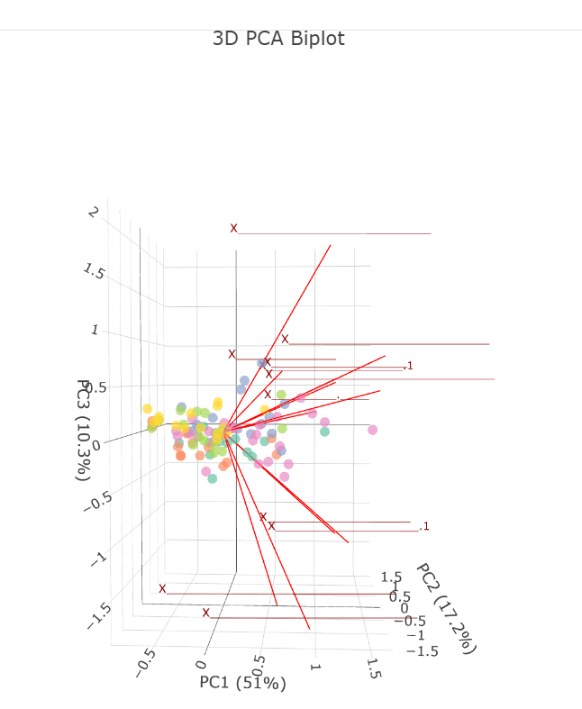
Figure 6: Interaction of the data through 3D visualization
Here it shows the shape variation across the dataset, with PC1 explaining 51%, PC2 17.2%, and PC3 10.3% of the total variance, together accounting for nearly 80% of the morphological variation. The samples cluster near the center, while the variable vectors (x1–x9) indicate how each trait contributes to the separation; x2 and x4 mainly shape the PC1/PC2 pattern, x6, x7, and x8 point in the opposite direction, and x9 contributes largely along PC3. Overall, these features appear to be the main drivers of morphological differentiation in the analysis.

